Change Management for DevOps Adoption

# Introduction

Here is a concise elucidation of Change Management, with practical suggestions on how to apply the concepts to promoting DevOps in an org.

The effort to bring the any organization to use DevOps is complex, will require the participation of many agents through a period measured in months. Failure to implement it will hinder the capacity to scale to the ever-growing customer needs. As such, it is an initiative in the realm of Change Management.

Considering that [70% of change programs fail](https://www.mckinsey.com/featured-insights/leadership/changing-change-management) to achieve their goals, largely due to employee resistance and lack of management support, it is better to improve the chances of success through proven practices. This document glosses over some theoretical aspects, providing pointers in case someone wants to dig deeper. However, it brings concrete suggestions on how to apply Change Management practices to this effort.

Text in italic was taken directly from technical literature.

# Which change management methodology to use?

Kotter-8, Plan-Do-Check-Act and Determine-Prepare-Implement-Sustain are the most used change management methodologies.

Plan-Do-Check-Act and Determine-Prepare-Implement-Sustain are simpler (4 steps instead of 8), but they do not obviate the need to include and communicate with many stakeholders to the change process.

Since most project failures are attributed to communication deficiencies, we'd better employ a change management approach that makes communication the central aspect of half of its steps: Kotter-8.

# Kotter 8

Dr. John Kotter (<https://www.kotterinc.com>) is a major figure in the business administration field, with foundational, authoritative publications on Change Management and in Marketing. He is for Business Administration what Donald Knuth is for Computer Science.

For Change Management, his approach is a cycle with 8 steps (he calls them “accelerators”):

1. Create a sense of urgency.
2. Build a guiding coalition.
3. Form a Strategic Vision and Initiatives.
4. Enlist a Volunteer Army.
5. Enable Action by Removing Barriers.
6. Generate Short-Term Wins.
7. Sustain Acceleration.
8. Institute Change.

Let’s look at how each accelerator can be used in the context of the effort to adopt DevOps at any organization.

# Create a Sense of Urgency

**Big opportunity:** Identify, articulate and communicate the big opportunity, listing the results in case we succeed or fail. It must be a common opportunity.

**Window of Opportunity:** Build urgency by calling attention to a window of opportunity that is open now but may close tomorrow.

## How to apply

Well, even though it seems obvious for the engineers, it is important to explain whether:

* The current situation is scalable.
  + If something happens to some key engineers (vacations, sick leave or quitting), no one knows what to do in case of problems with deployment and operations.
  + The product is growing in complexity and geographies.
* Data points regarding organizations with DevOps against non-DevOps:
  + 200 times more frequent code deployments
  + 2,555 times faster lead times
  + 24 times faster mean time to recover
  + 3 times lower change failure rate

# Build a guiding coalition

*Without a Guiding Coalition, the organization will continue to rely on traditional, hierarchical ways of operating which often act in ways that kill off, rather than accelerate, needed change.*

*Engage beyond the “usual suspects” in your organization. You need more eyes to see, more brains to think, and more hands to do to accelerate your change efforts.*

*Diversity of the team in terms of level, function, geographic location (if applicable), tenure, and ideas.*

*An ability and a willingness to work across the hierarchy while also working with people across all levels and functions...with respect and energy and a commitment to the change initiative at hand.*

## How to apply

Get a small group of committed, opinionated and diverse people that can help you define the Vision (see next accelerator).

# Form a Strategic Vision and Initiatives

*Characteristics of a good strategic vision:*

* *Communicable, Desirable, Creates, a, Verbal, Picture, Flexible, Feasible, Imaginable, Simple.*
* *Motivates people to take action.*
* *Coordinates and aligns their actions.*
* *Without it, strategic initiatives can struggle to get activity behind them.*
* *Clarifies how the future will be different from the past, and how that future will become a reality.*
* *Ties directly to the* [*Big Opportunity*](https://microsoft-my.sharepoint.com/personal/lumayerk_microsoft_com/Documents/ChangeManagementForDevOpsPushInPlayFab.docx#_Create_a_Sense)*.*

## How to apply to our case

As a suggestion, a good vision could be: “Achieve ‘High IT Performer’ status according to the classification from State of DevOps report, by the first quarter of 2020.”

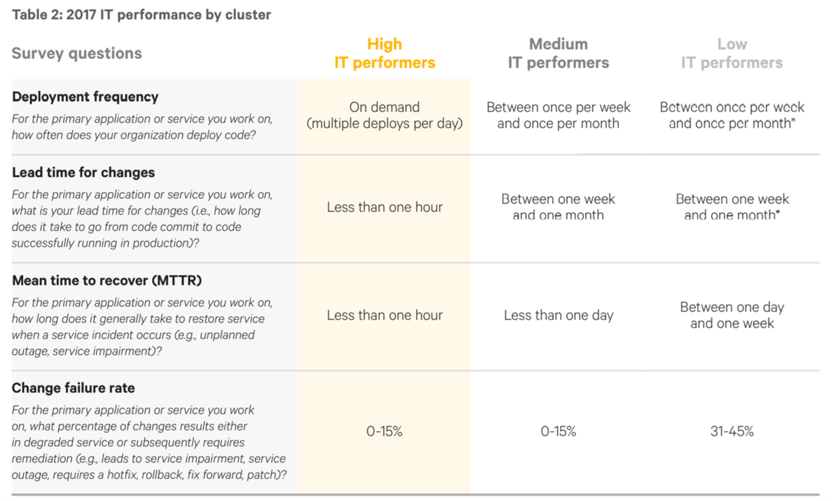

# Enlist a Volunteer Army

*Large-scale change can only occur when very significant numbers of people amass under a common opportunity and drive in the same direction.*

*Give people a reason and motivation to join the movement. A* [*strong vision*](https://microsoft-my.sharepoint.com/personal/lumayerk_microsoft_com/Documents/ChangeManagementForDevOpsPushInPlayFab.docx#_Form_a_Strategic) *goes a long way.*

*Don’t boil the ocean –while you reach “stickiness” once you surpass 50%, about 15% of your organization is enough to build material momentum toward change.*

*Recognize the effort of existing volunteers to keep them engaged and to recruit more.*

## How to apply

A virtual team with buy-in from Senior Leadership.

# Enable Action by Removing Barriers

*By removing barriers such as inefficient processes and archaic norms, leaders provide the freedom necessary for employees to work across boundaries and create real impact.*

*Many leaders agree that even their own management practices are too bureaucratic and are a nuisance, yet remnants of the past can have tremendous staying power.*

*To remove barriers, you must identify them. Think about why past initiatives have failed. At what stage? Did they get off the ground at all? Stall mid-way? Get completed but then abandoned?*

*Barriers can be commonly accepted statements that, while appearing helpful, can deter attempts to get past legacy obstacles. These are statements like, "It's just not done that way," or "We tried that before —it didn't work.”*

*Common barriers include: silos, parochialism, pressure to hit numbers, complacency, legacy rules or procedures, and limited access to key stakeholders and leaders.*

## How to apply

People that will join this effort surely will stumble upon ill-documented areas of our processes, or simply complicated parts that no matter how much documentation it would be daunting to understand.

For a Tech Lead, it is important to identify these gray areas / black holes beforehand and either document them, automate them or have brown bags. It is also advisable to have someone else able to perform at least 70% of what you do, so you can continue with your head up most of the time.

# Generate Short-Term Wins

*A win is anything –big or small –that helps you move toward your opportunity. They may take the shape of actions taken, a lesson learned, a process improved, a new behavior demonstrated, etc.*

*Results: a body of data that tells the story of your transformation in validated, quantifiable, and qualifiable terms.*

*Relevant in light of the opportunity before you.*

*Meaningful to others. People beyond the winner or winners care about the win, be it members of your team, another team, customers, stakeholders, etc.*

*Unambiguous, visible, and tangible such that people can replicate or adapt it. Wins have the most impact when they scale across organizations.*

## How to apply

Break the Vision into logical, attainable Epics. Create Features, User Stories and Tasks as you have more clarity for each Epic (using [BDD](https://playfab.visualstudio.com/PlayFab/_wiki/wikis/pf-main.wiki?pagePath=%2FEngineering%2FDev%20environment%20and%20tools%2FBehavior%20Driven%20Development%20(BDD)%20with%20Specflow&wikiVersion=GBwikiMaster&pageId=423), preferably). Get realistic estimates using Planning Poker, then follow-up daily against estimates. Act immediately when slipping is detected.

Commemorate loudly whenever a new part is implemented.

# Sustain Acceleration

*Press harder after the first successes. Your increasing credibility can improve systems, structures and policies. Be relentless with initiating change after change until the vision is a reality.*

*So you’ve had a few wins. It can be easy to lift your foot off the gas pedal after experiencing some success. Instead, this is the time to press harder and use those wins as momentum to further fuel the change.*

*Revisit urgency after generating some  significant wins. It is so easy to lose sight of the ultimate goal, which is to move the initiatives into the culture and sustain them. It may be necessary to revisit some of the urgency-raising activities incorporated at the start.*

*Get more and more people involved, always looking for ways to expand the volunteer army.*

*With new volunteers and fresh eyes, you’ll find more barriers in need of knocking down. Remove them, too!*

## How to apply

Review the [Big Opportunity](https://microsoft-my.sharepoint.com/personal/lumayerk_microsoft_com/Documents/ChangeManagementForDevOpsPushInPlayFab.docx#_Create_a_Sense) and the [Vision](https://microsoft-my.sharepoint.com/personal/lumayerk_microsoft_com/Documents/ChangeManagementForDevOpsPushInPlayFab.docx#_Form_a_Strategic), at least once a week. Recruit more people. Communicate, communicate, communicate: create and distribute reports (with lots of colorful boxes indicating progress).

# Institute Change

*To ensure new behaviors are repeated over the long term, it's important that you define and communicate the connections between those behaviors and the organization's success.*

*Years of a different kind of experience are often needed to create lasting change. That is why cultural changes come once you are deep into a transformation, not at the beginning. You first have to build the muscle and track record of antithetical experiences. Culture changes after you have successfully altered people’s actions, connecting the dots between new behaviors and better performance.*

*Accelerators 1-7 are all about building new muscles, new behaviors and new ways of working. Accelerator 8 is about sustaining it long into the future.*

*New practices must be deeply rooted and anchored to replace the old ways. There must be clear communication and synchronization between the traditional hierarchical structure and the innovative network of volunteers.*

*A key challenge is grafting the new practices onto roots that may be old but still effective, while killing off the inconsistent pieces.*

## How to apply

Document the new processes with the goal that even a total newbie can follow them productively, with any chance of disaster.

Make sure previous practices (such as writing wonky ad-hoc scripts) are not attainable.

Put telemetry so anyone can review the state of the new processes and infer the new [Big Opportunity](https://microsoft-my.sharepoint.com/personal/lumayerk_microsoft_com/Documents/ChangeManagementForDevOpsPushInPlayFab.docx#_Create_a_Sense). Perform a Retrospective review, list what went right and what went wrong, and what could be the next [Big Opportunity](https://microsoft-my.sharepoint.com/personal/lumayerk_microsoft_com/Documents/ChangeManagementForDevOpsPushInPlayFab.docx#_Create_a_Sense).

Most important: **Do not rest on your laurels!**

# Resources

<https://puppet.com/resources/whitepaper/2016-state-of-devops-report>

<https://puppet.com/resources/whitepaper/2017-state-of-devops-report>

<https://puppet.com/resources/whitepaper/2018-state-of-devops-report>

<https://www.mckinsey.com/featured-insights/leadership/changing-change-management>

Development and Deployment at Facebook  <https://ieeexplore.ieee.org/abstract/document/6449236>